Practical - 6
Practical Title: Rendering External JSON Data using Fetch API, Search and Filter
Display event lists, student profiles, notices, or FAQs from external JSON files using Fetch API. Implement dynamic rendering, search, filter, sorting, and pagination.

Theory

1. How is JSON fetched, parsed, and rendered?
JSON data is fetched from a JSON file or API using the JavaScript fetch() method. The response is converted into a JavaScript object using response.json(). The data is then processed and dynamically displayed on the webpage by creating or updating HTML elements using DOM methods.

2. Which array methods are used for search, filter, sort, and pagination?
- Search: includes() or find() is used to search for matching data.
- Filter: filter() is used to display only records that satisfy a condition.
- Sort: sort() is used to arrange records in ascending or descending order.
- Pagination: slice() is commonly used to select a specific range of records for each page.

3. How are loading and error states handled?
A loading message is displayed while the JSON data is being fetched. The fetch() operation uses .catch() to handle errors such as network failure or invalid data. If an error occurs, a user-friendly error message is displayed instead of leaving the page blank.

4. How is modularity maintained in JavaScript files?
Modularity is maintained by dividing the JavaScript code into separate files or functions based on their responsibilities. For example, one part can handle data fetching, another can handle search/filter/sort, and another can handle DOM rendering. This makes the code easier to understand, test, maintain, and reuse.

Evidence of Work (Screenshots)

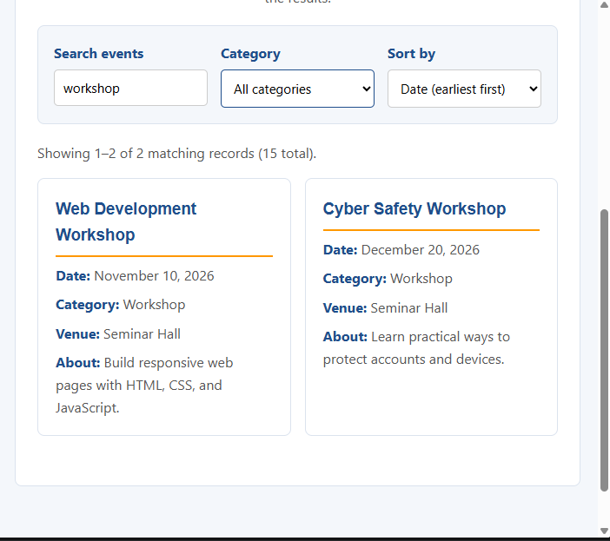

Description:

This practical focuses on fetching data from a JSON file or API and dynamically displaying it on a webpage using JavaScript. The JSON data is fetched using the fetch() method, parsed into JavaScript objects, and rendered through DOM manipulation. Array methods such as filter(), find(), sort(), includes(), and slice() are used to implement searching, filtering, sorting, and pagination. Loading and error messages are provided to improve the user experience when data is being fetched or when an error occurs. The JavaScript code is divided into separate functions or modules to maintain modularity, readability, reusability, and easy maintenance.

GitHub Repository Link:

https://github.com/archibhatt091601

Challenges Faced
· Understanding how to fetch JSON data using the fetch() method.
· Handling asynchronous operations and displaying a loading message while data was being fetched.
· Parsing JSON data and displaying it dynamically using DOM manipulation.
· Implementing search, filter, sorting, and pagination using JavaScript array methods.
· Handling errors such as unavailable or invalid JSON data.
· Organizing JavaScript code into separate functions to maintain modularity.

Learning Outcome
- Learned how to fetch and parse JSON data using JavaScript.
- Understood how to dynamically render data on a webpage using DOM manipulation.
- Learned to use array methods such as filter(), find(), sort(), includes(), and slice().
- Understood how to implement search, filtering, sorting, and pagination.
- Learned to handle loading and error states for better user experience.
- Improved understanding of modular and maintainable JavaScript code.

